3. Deliverable 3: System Design
Software Design Document
Phase 3 of the lms project
tools used for diagrams:
python graphiviz
matplotlib
pillow
2026

3.1. Architecture and Component Diagram.

3.1.1. Architectural Decision
Chosen style: Layered Architecture

The LMS will be one application organized into separate logical layers and modules. It will not be split into independently deployed microservices.
For deployment, I recommend a central school computer on the local network, with the application and database hosted there. Internet access will not be required for the core LMS functions. For persistent storage, the LMS will use a local SQLite database to store user accounts, courses, assignments, submissions, marks and moderation records. The database will preserve records when the application closes and restarts. Database operations will be separated from the academic business logic to support maintainability and testing.
This is a reasonable design choice for the case study; it keeps the implementation manageable while allowing the storage technology to be selected according to the school’s deployment needs.

3.1.2. Architecture Rationale
The layered architecture was selected for four main reasons:
- Separation of concerns. The user interface does not need to know how late penalties are calculated or how a submission is stored. Those responsibilities belong to different components.
- Testability. The submission and moderation services can be tested independently of the GUI and database by supplying test implementations of their repository interfaces.
- Maintainability. If the school changes the late-submission policy, the team can modify the penalty strategy without rewriting the submission screens or database access code.
- Controlled complexity. A modular monolith is simpler to develop and deploy than a distributed microservices system, while still separating the LMS's major responsibilities.

Alternative Rejected: Multi-services Architecture
- Microservices would split the LMS into independently deployed services, potentially for authentication, assignments, submissions and marking.
- This alternative was rejected because it would introduce network communication between services, distributed deployment, and additional failure and testing concerns. Those costs are not justified for a school LMS being developed as a C++ console or simple desktop application on a local computer or network.

3.1.3. Component Diagram
<<component>>
User Interface
Console Menus

User Requests
SQL operations

Read/ write requests
Uses business rules
<<database>>
Local SQLite Database
<<component>>
Data Access
Repository/ DAO
<<component>>
Domain Logic
Role Permission · Deadline rules
Late Penalties · Mark approval
<<component>>
LMS Application Services
Login · Courses ·
Assignments
Submissions · Marking ·
Moderation

Component Diagram Description:
- The LMS uses a layered architecture consisting of the User Interface, Application Services, Domain Logic and Data Access components.
- The User Interface sends requests to the Application Services, which coordinate the required operations.
- The Domain Logic enforces the system's academic and access-control rules.
- The Data Access component communicates with the local SQLite database to store and retrieve information.
- This separation reduces coupling and makes the application easier to maintain and test. The design is suitable for a small C++ LMS that operates locally without requiring Internet access.

3.2. Class Diagram.

UML Class Diagram
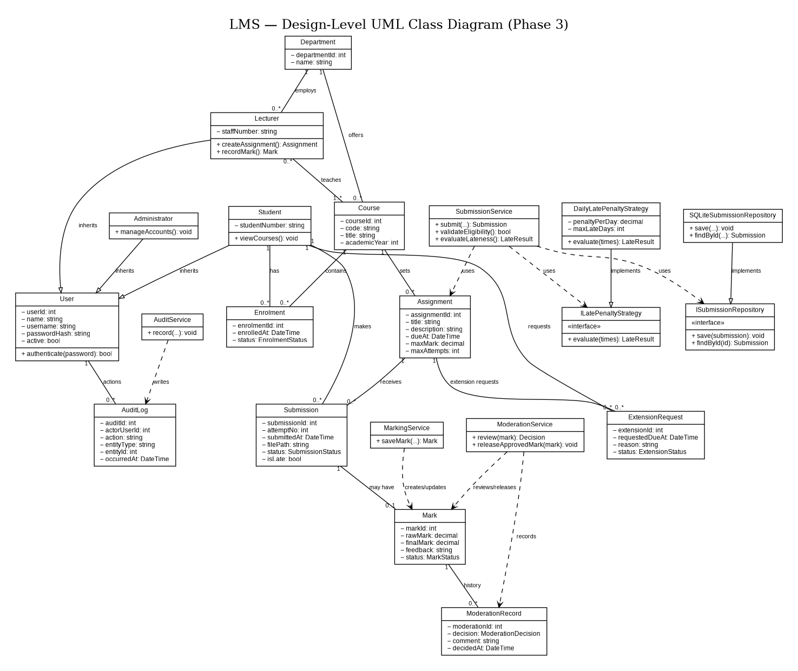

3.2.1 Design Patterns and SOLID Principles.
The Repository pattern separates data access from application logic. SubmissionService and MarkingService use the ISubmissionRepository interface instead of directly accessing the database. SubmissionRepository implements that interface, allowing the persistence implementation to be changed without rewriting the services.
The Strategy pattern separates late-penalty calculation from marking. MarkingService uses ILatePenaltyStrategy, implemented by DailyLatePenaltyStrategy. This keeps the penalty rule in one place and allows an approved alternative rule to be introduced without changing the marking service.
The design supports SOLID principles in the following ways:
- Single Responsibility: classes have focused responsibilities—for example, SubmissionService handles submission workflows, while repositories handle persistence.
- Open/Closed: a new late-penalty policy can implement ILatePenaltyStrategy without modifying MarkingService.
- Liskov Substitution: role subclasses can be used where a User is expected, provided they preserve the parent class’s behavior.
- Interface Segregation: repository and penalty interfaces expose only the operations their clients need.
- Dependency Inversion: services depend on repository and penalty interfaces rather than concrete database or policy classes.
The late-penalty formula, permitted resubmissions, extension rules, and mark-release policy must follow the requirements approved by the school; the diagram shows where those rules belong, not an independent decision about school policy.

3.3. Behavioral Models.

3.3.1 Submission Life-Cycle State Machine:

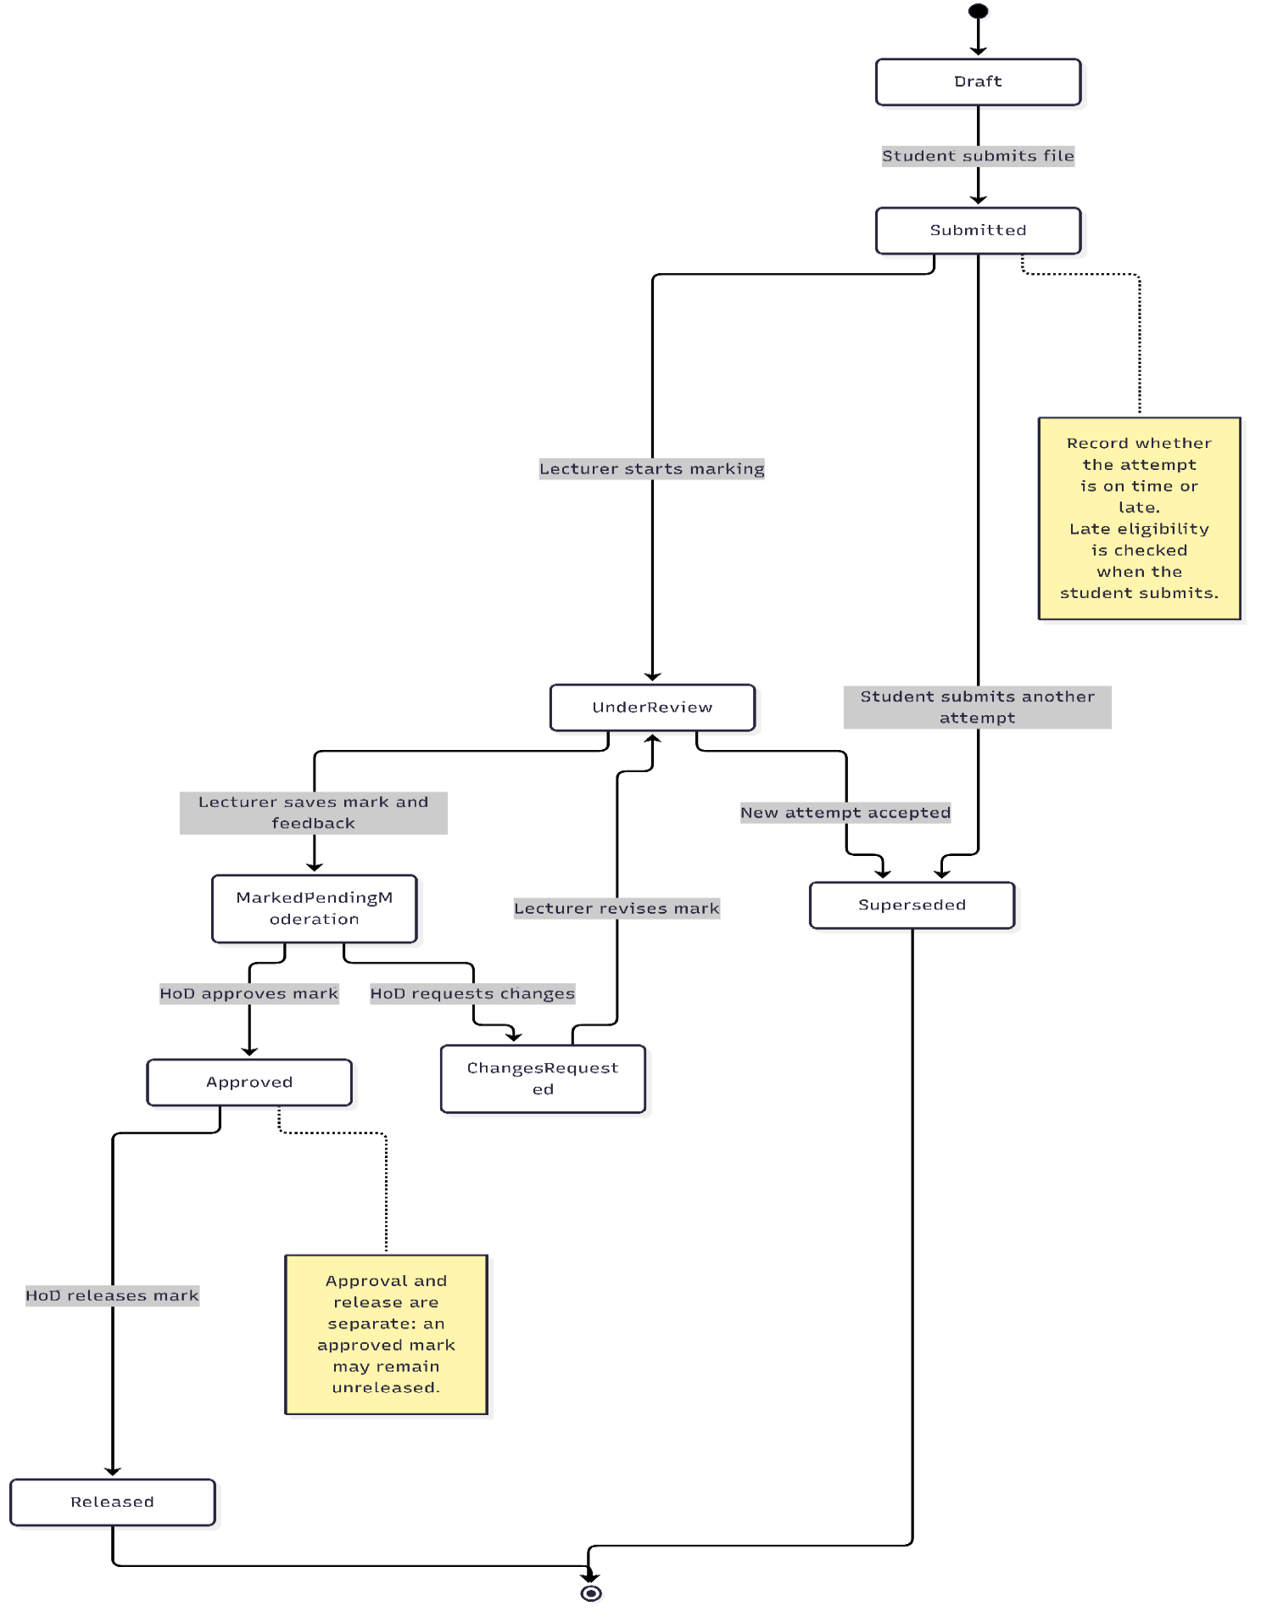
The state machine separates submission, marking, moderation, and release. A mark is not visible to the student merely because a lecturer has entered it; it becomes visible only after the HoD releases it. If a student resubmits, the new attempt is recorded separately and the earlier attempt is retained as superseded.
Policy check: This diagram assumes the HoD can request marking changes and that a lecturer can revise a mark. If your requirements do not include “request changes,” remove that state and transition.

3.3.2. Activity Diagram With Swimlanes: Submission To Released Mark.
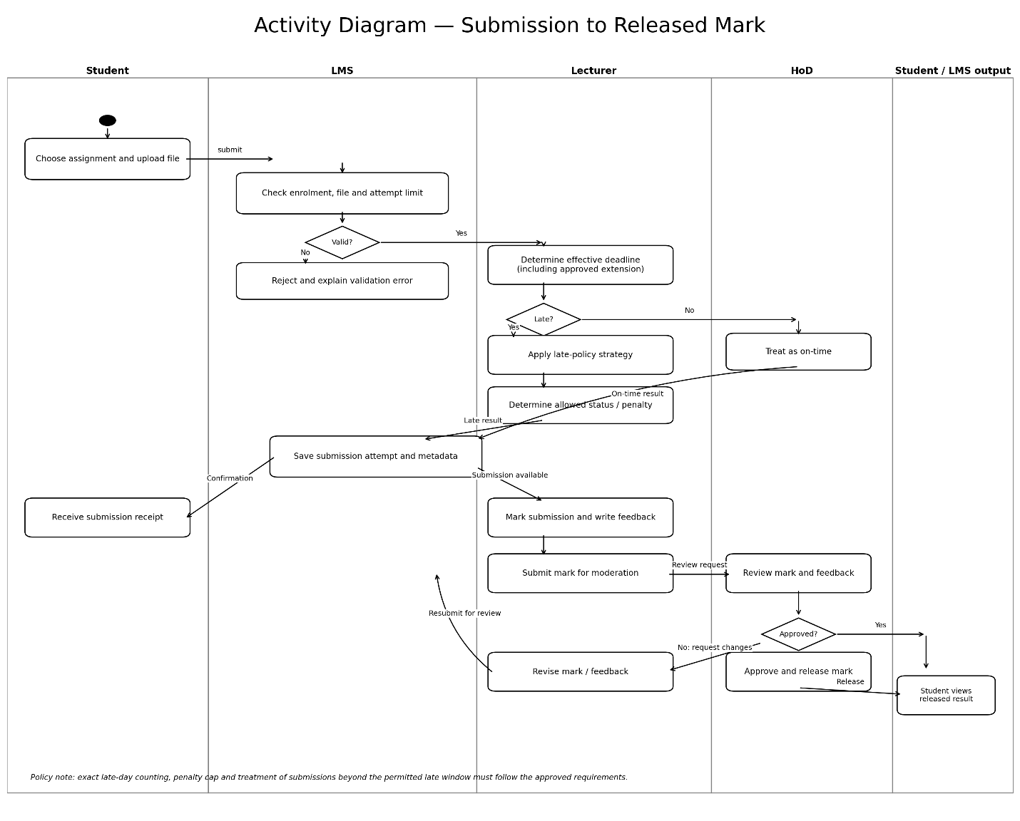

Swimlane interpretation: The student provides the work; the LMS validates and records it; the lecturer assesses it; and the HoD moderates and releases the mark.

`3.3.3. Sequence Diagram 1: Submit Assignment.
This sequence diagram includes the normal submission path, a late submission path, and resubmission. The LMS checks the effective deadline, which should account for an approved extension.

What the diagram below demonstrates:
- The service retrieves the assignment and its effective deadline.
- It checks whether the student is submitting for the first time or resubmitting.
- An accepted late submission is stored and flagged; the late penalty is applied during marking.
- A submission outside the permitted window is rejected only if that is what the approved policy specifies.
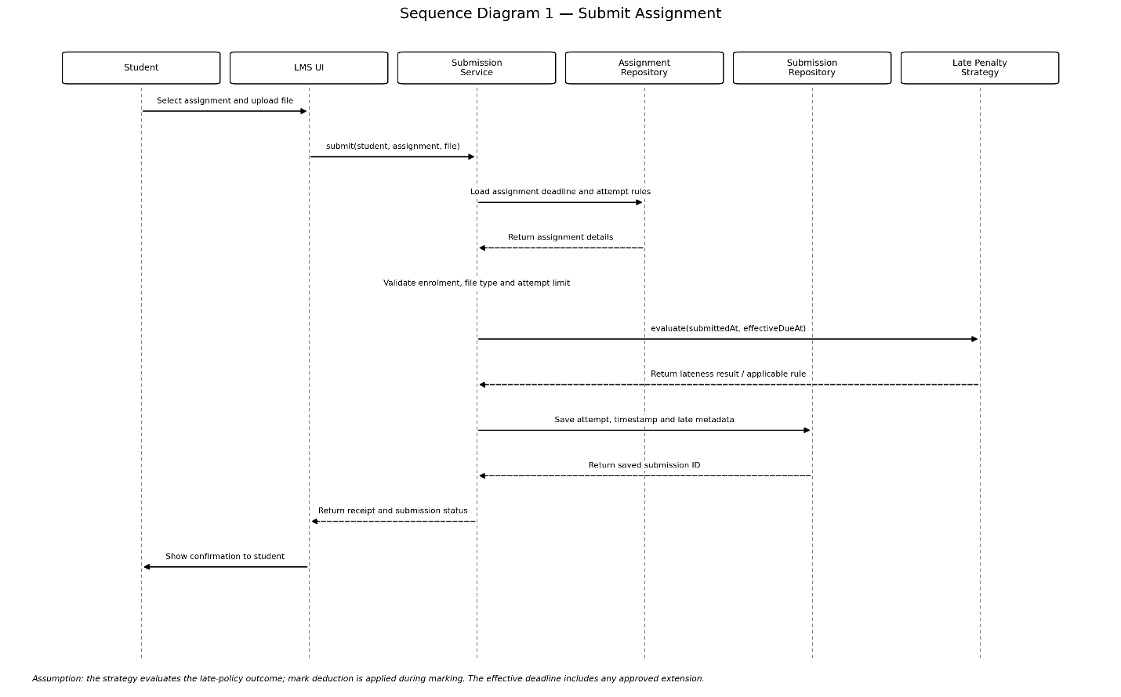

3.3.4. Sequence Diagram 2: Moderate And Release Marks.
This sequence covers lecturer marking, HoD moderation, a possible request for correction, approval, and release.

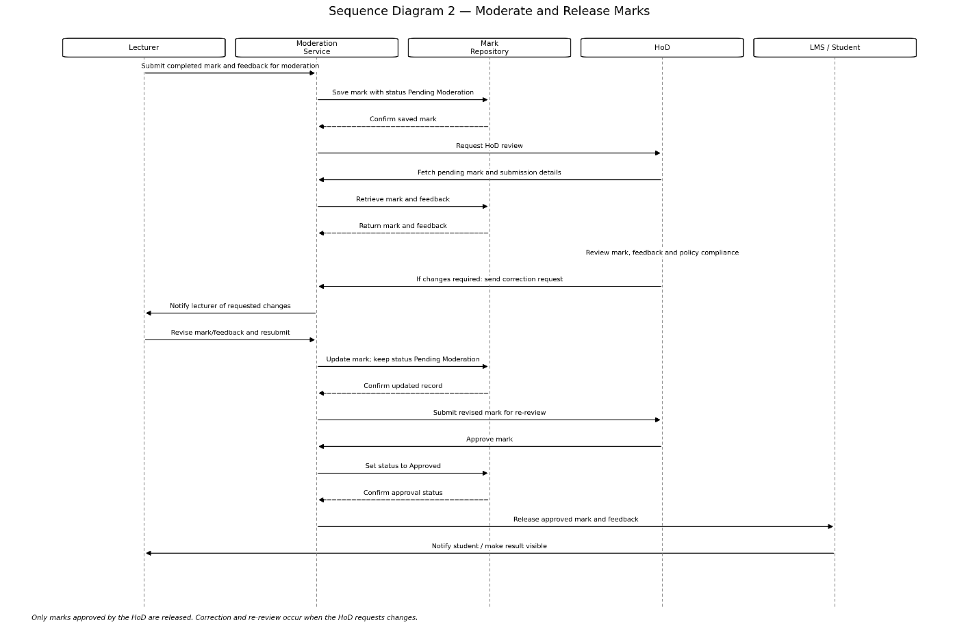

Behavioral Models:
The behavioral models describe how an assignment submission progresses through the LMS, from student submission to the release of a moderated mark. The submission state machine identifies the important states and transitions of a submission. The activity diagram presents the end-to-end workflow using Student, LMS, Lecturer, and Head of Department swimlanes. The sequence diagrams show the interactions between the student interface, application services, repositories, lecturer, and HoD during assignment submission and mark moderation.
The models distinguish marking, moderation approval, and mark release. They also represent late submissions and resubmissions as paths that are validated by the LMS. The precise late-submission cutoff, resubmission rules, and moderation procedure must follow the policies approved in the requirements phase.

3.4. Database Design.
3.4.1. ERD
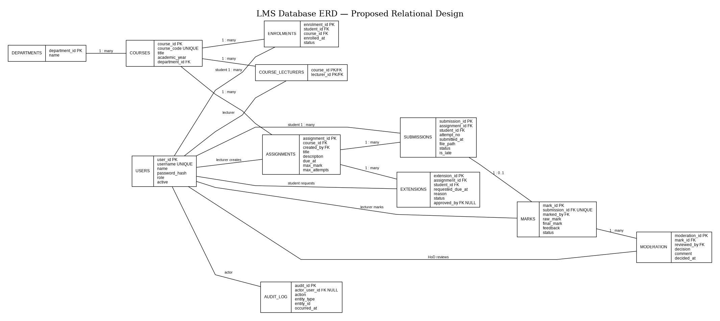
3.4.2. Data Dictionary
Mapping the class diagram to database tables:
UML class | Database table(s) | Mapping
User | users | Common account attributes are stored once.
Student, Lecturer, Administrator | users | Stored using a single-table inheritance approach: the role column identifies the account type.
Department | departments | One row per department; hod_user_id identifies its HoD.
Course | courses | One row per course.
Lecturer–Course association | course_lecturers | Junction table for the many-to-many relationship.
Enrolment | enrolments | One row per student-course enrolment.
Assignment | assignments | One row per assignment.
Submission | submissions | One row per attempt, so resubmissions retain their history.
ExtensionRequest | extensions | One row per extension request.
Mark | marks | One row per marked submission; the unique submission FK enforces at most one current mark record per attempt.
ModerationRecord | moderation_records | Multiple records can be kept for a mark to preserve re-review history.
AuditLog | audit_log | One row per logged action.
SubmissionService, MarkingService, ModerationService, AuditService | No direct tables | These are application-service classes; they operate on the entities and repositories rather than representing stored records.
ILatePenaltyStrategy and its implementation | No direct table in this draft | The strategy is application logic. If administrators must configure penalty rules without changing the program, policy configuration could be stored in a separate table.
Repository interfaces/implementations | No direct tables | Repositories provide access to stored entities; they are not domain records.

- The design above uses SQLite, which fits the project’s local/offline application approach. It separates information into related tables, uses primary and foreign keys, and avoids storing the same facts redundantly—core relational design principles.

3.4.3. Normalisation and Integrity:
The schema is intended to be in Third Normal Form (3NF):
- Each table has a primary key, and fields hold single values rather than lists.
- Course details are stored in courses, not repeated in every enrolment or submission.
- Student-course registration is separated into enrolments.
- Lecturer-course assignments use a junction table.
- Submission attempts are separate rows, so one attempt’s timestamp or file path does not overwrite another’s.
- Moderation decisions are stored as records, preserving the review trail.
- The SQL also includes constraints such as unique usernames, unique course codes, unique enrolment per student/course, unique attempt numbers per student/assignment, and valid status values.

